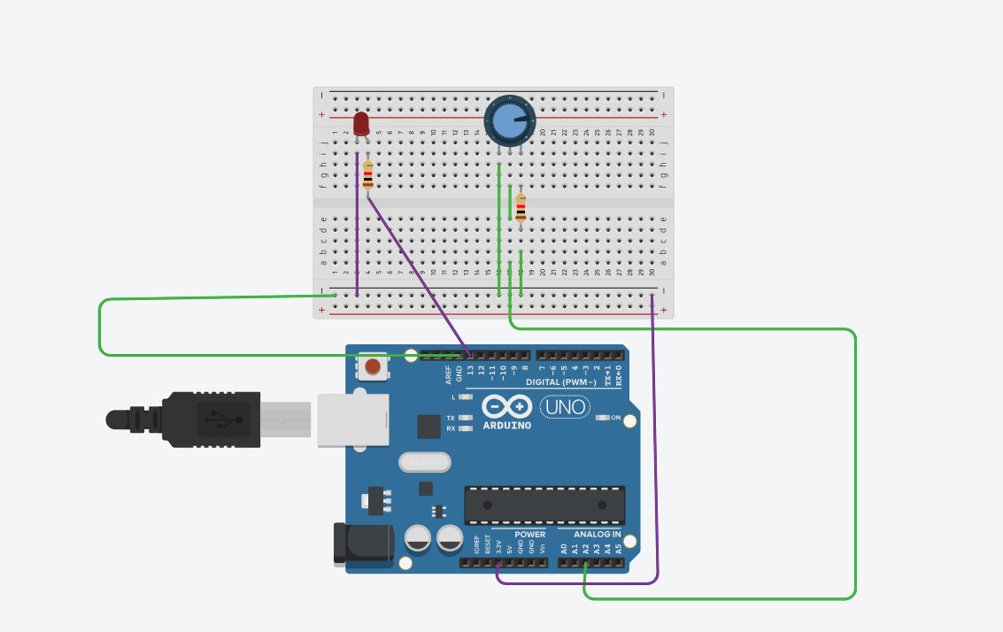
CODE:
const int ledPin = 13;
const int potPin = A2;

void setup()
{
pinMode(ledPin, OUTPUT);
}

void loop()
{
digitalWrite(LED_BUILTIN, HIGH);
delay(1000); // Wait for 1000 millisecond(s)
digitalWrite(LED_BUILTIN, LOW);
delay(1000); // Wait for 1000 millisecond(s)
}

